Assessing the Capacity of the Health Care System to Handle Neglected Tropical Diseases in a Refugee Settlement in Uganda

Abstract
Background: Neglected Tropical Diseases (NTDs) disproportionately affect over one billion people globally, particularly the poorest communities, with Uganda facing a significant burden where over 40 million people are at risk. Despite global efforts by the World Health Organization (WHO) to integrate NTD management into primary healthcare (PHC) systems, the capacity of health facilities in refugee settings to diagnose and manage these diseases remains largely unknown. This study aimed to assess the capacity of PHC facilities in Nakivale Refugee Settlement, Uganda, focusing on health workers' knowledge of NTDs (specifically soil-transmitted helminths and schistosomiasis), and the perceived facilitators and barriers to their diagnosis and management.
Methods: A quantitative, cross-sectional study was conducted using a questionnaire administered to 150 health workers in Health Centre III (HCIII) and Health Centre IV (HCIV) facilities within Nakivale Refugee Settlement. Data collected included demographic information, previous NTD training and supervision, perceived ease of NTD reporting, and knowledge of NTD subtypes, symptoms, and medications. Descriptive statistics, including frequencies, percentages, means, and standard deviations, were used for analysis. Multi-select questions were analyzed to identify the most common responses.
Results: The study population comprised 150 health workers, predominantly female (60%) with a mean age of 31.5 years, mostly holding diplomas or certificates. A striking 88% of health workers reported no previous training on NTDs, and 84% had not received supportive supervision for NTDs. While 39% found NTD reporting easy, 38% found it difficult, and 17% felt it was very difficult. Furthermore, 71% reported that the NTD reporting form was not easy to fill. Regarding knowledge, 65% knew about S. Haematobium and 58% about S. Mansoni. Knowledge of helminth subtypes like Hookworms (95%), Roundworms (92%), and Tapeworms (91%) was high. Common symptoms of S. Haematobium (anaemia, haematuria) and S. Mansoni (abdominal pain, diarrhoea) were widely recognized. Albendazole/Mebendazole for STH was known by 97% of respondents, and Praziquantel for schistosomiasis by 74%.
Conclusion: The findings reveal a critical gap in NTD-specific training and supportive supervision among health workers in Nakivale Refugee Settlement. While basic knowledge of common NTD types, symptoms, and medications exists, the lack of formal training and the perceived complexity of reporting systems pose significant barriers to effective NTD management. Targeted interventions focusing on comprehensive training, structured supervision, and simplification of reporting mechanisms are crucial to enhance the capacity of PHC facilities and facilitate the integration of NTD programs in refugee settings, thereby accelerating the realization of Sustainable Development Goal 3.

Introduction
Neglected Tropical Diseases (NTDs) represent a group of chronic, debilitating infections caused by parasitic worms, protozoa, or bacteria, currently afflicting over one billion people globally, with an additional billion at risk of infection [1-8]. These diseases disproportionately impact the world’s poorest populations, exerting severe adverse effects on their health, well-being, and socioeconomic development [2, 9-11]. Africa bears a substantial portion of this global burden, accounting for over 600 million cases, particularly affecting rural poor communities [1-2, 12]. In Uganda, the situation is dire, with more than 40 million people at risk for one or more NTDs, making it endemic for all five NTDs targeted by USAID’s Act to End NTDs [13].
Despite their significant burden, NTDs are largely preventable and amenable to elimination. In 2020, the World Health Organization (WHO) outlined a roadmap for the eradication and elimination of 20 NTDs by 2030 [14]. The WHO, alongside policymakers and academics, advocates for the integration of NTD management into existing public health programs within endemic countries. Such integration is posited to contribute significantly to achieving several Sustainable Development Goals (SDGs) and vice versa [14-16]. However, despite the pressing burden of NTDs in Sub-Saharan Africa, their integration into primary healthcare (PHC) systems in most countries remains suboptimal. Previous studies in Nigeria, Tanzania, and Burundi have consistently reported low capacity and readiness among health workers to diagnose and manage NTDs [1, 17-18].
Refugee settlements present unique health vulnerabilities that can exacerbate the prevalence of NTDs. Overcrowded living conditions and inadequate sanitation within these camps create conducive environments for the propagation of vectors and parasites associated with diseases like leishmaniasis and schistosomiasis [20-21]. Furthermore, refugees often encounter significant barriers to accessing healthcare, including logistical, legal, and language challenges, which impede timely medical intervention and amplify the burden of NTDs in these vulnerable populations [22].
Nakivale Refugee Settlement, the eighth-largest settlement globally, hosts approximately 145,613 refugees from ten different nationalities [19]. Within this settlement, NTDs, particularly schistosomiasis and Soil-Transmitted Helminths (STHs), are prevalent, with reported rates of 26.6% and 26.5% respectively [23]. The escalating number of refugees coupled with inadequate resources raises critical questions about the capacity of the existing health system to effectively diagnose, manage, and treat these NTDs. Moreover, there is a notable scarcity of comprehensive data on NTDs and their prevalence in regions like South Western Uganda. Currently, Uganda's national strategy for NTDs involves integrated control programs [24]. The Ministry of Health has identified several hindrances to the elimination of NTDs by 2030, including a lack of knowledge, skills, and equipment for diagnosis and management in health facilities, as well as deficiencies in reporting systems [23].
Exploring the readiness and capability of PHC facilities to diagnose and manage NTDs is paramount, as it provides a crucial baseline for tracking progress and informing targeted interventions. This study specifically aims to assess the readiness and capacity of PHC centers in Nakivale Refugee Settlement to diagnose and manage soil-transmitted helminths and schistosomiasis. The findings from this research are expected to inform and guide policy enactment and healthcare service provision in refugee settings, thereby facilitating the integration of NTDs into PHC and accelerating the realization of SDG 3.

Main Objective
To assess the capacity of primary healthcare centers to timely diagnose, treat, and manage soil-transmitted helminths and schistosomiasis among refugees in Nakivale Refugee Settlement, South Western Uganda.

Specific Objectives
- To assess the knowledge of health workers on soil-transmitted helminths and schistosomiasis in Nakivale Refugee Settlement, South Western Uganda.
- To assess the availability of diagnostic tools, diagnostic equipment, and medications for soil-transmitted helminths and schistosomiasis in Nakivale Refugee Settlement, South Western Uganda.
- To analyze the facilitators and barriers to diagnosing and successfully managing schistosomiasis and soil-transmitted helminths in refugee populations in Nakivale Settlement, Uganda.

Methods

Study Design and Setting
This study employed a quantitative, cross-sectional design to assess the capacity of the health care system to handle NTDs. The study was conducted in Nakivale Refugee Settlement, located in South Western Uganda, which hosts a diverse refugee population.

Study Population and Sampling
The study population comprised health workers actively engaged in primary healthcare facilities (Health Centre III and Health Centre IV) within the Nakivale Refugee Settlement. A total of 150 health workers participated in the study.

Data Collection
Data were collected using a structured quantitative questionnaire administered to the health workers. The questionnaire was designed to gather information on several key areas:
- Demographic characteristics: Age, gender, type of health facility, education level, and position held.
- Training and supervision: Any previous training on NTDs (soil-transmitted helminths, schistosomiasis) and whether they had received supportive supervision for NTDs.
- Reporting systems: Perceived ease of reporting NTDs, knowledge of the NTD reporting form, and opinions on whether monetary incentives promote reporting.
- Knowledge of NTDs: This included questions on knowledge of schistosomiasis subtypes (S. Haematobium, S. Mansoni), helminth subtypes (Hookworms, Roundworms, Flat worms, Tape worms, Flukes), symptoms of S. Haematobium and S. Mansoni, presentation of STHs (hookworm, Ascaris, whipworm), and medications used in the management of STH and schistosomiasis.

Data Analysis
The collected data were analyzed using Python, leveraging the Pandas library for data manipulation and Matplotlib for visualization.
- Data Cleaning: Column names were standardized by stripping leading/trailing spaces and replacing multiple spaces with single spaces for consistency.
- Descriptive Statistics: For continuous variables such as 'Age in years', descriptive statistics (mean, standard deviation, min, max, quartiles) were calculated. For categorical variables (e.g., Gender, Type of Health Facility, Education level, Position held, Training status, Supervision status, Reporting ease, Form ease, Monetary incentives), frequencies and percentages were computed.
- Multi-select Questions Analysis: Questions allowing multiple responses (e.g., knowledge of symptoms, subtypes, medications) were processed by splitting the responses (which were semi-colon separated) and then using collections.Counter to count the occurrences of each individual option. This allowed for the identification of the most commonly known symptoms, subtypes, and medications.
- Visualizations: Histograms were generated for age distribution, and bar plots were created for categorical variables to visually represent their distributions.

Results

Demographic Characteristics of Health Workers
The study involved 150 health workers. The mean age of the respondents was 31.5 years (SD = 6.41), with ages ranging from 21 to 61 years (Figure 1). A majority of the respondents were female (60%, n=90), while 40% (n=60) were male (Figure 2). Most health workers were employed at Health Centre III (HCIII) facilities (74%, n=111), with the remaining 26% (n=39) at Health Centre IV (HCIV) facilities (Figure 3). In terms of education, 46% (n=69) held a Diploma, 44% (n=66) had a Certificate, and 10% (n=15) possessed a Degree (Figure 4). The most prevalent positions held were Enrolled Nurse (29%, n=43), Enrolled Midwife (25%, n=38), and 'Other' (23%, n=34), followed by Clinical Officer (17%, n=26), Medical Officer (5%, n=7), and Medical Superintendent (1%, n=2) (Figure 5).

Figure 1: Distribution of Age in Years
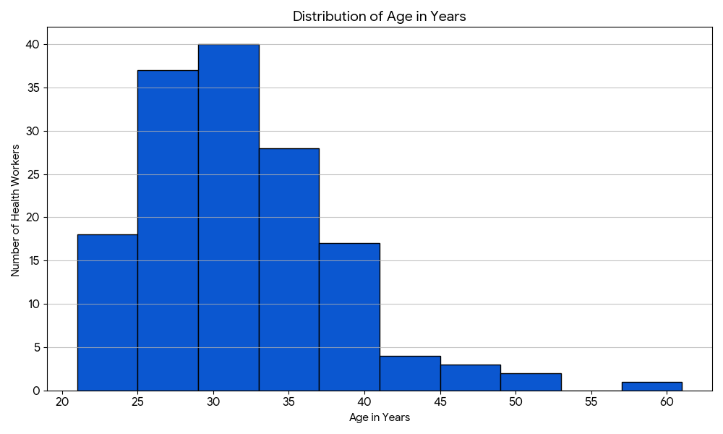

Figure 2: Distribution of Gender
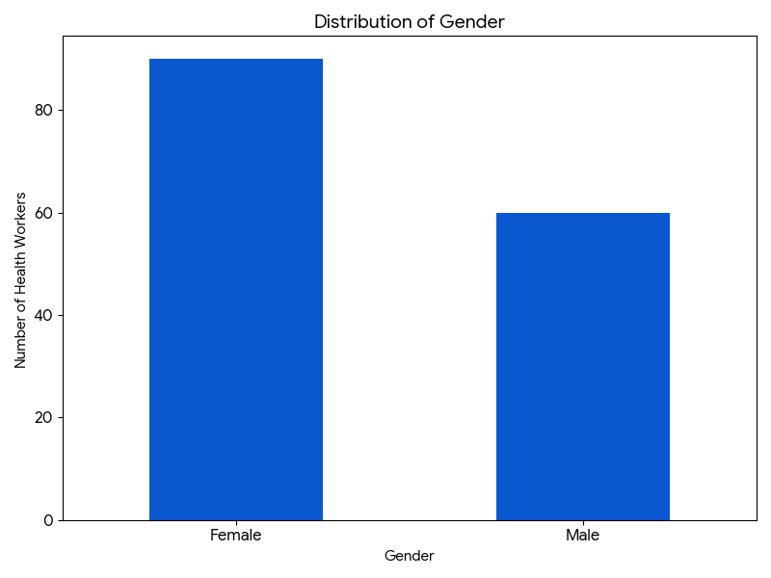

Figure 3: Distribution of Type of Health Facility
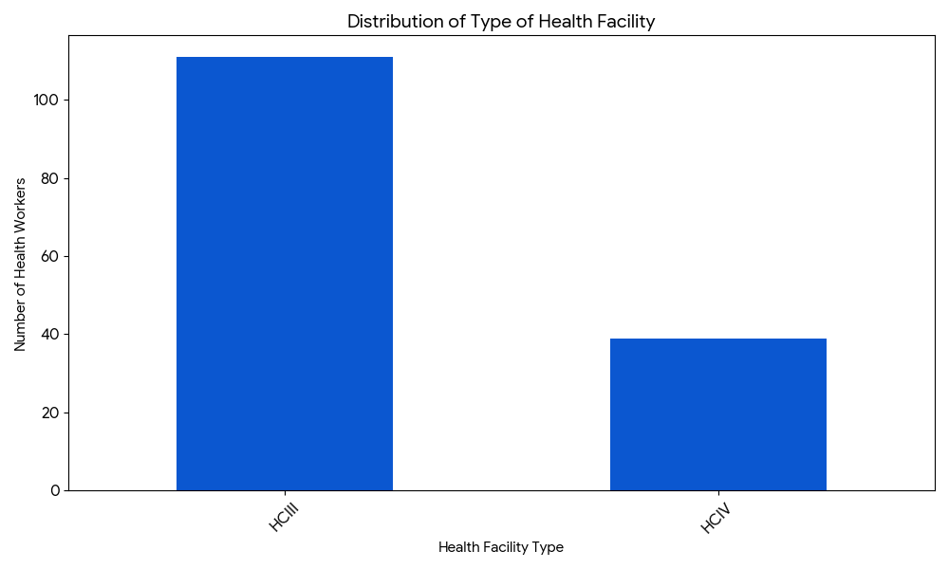

Figure 4: Distribution of Education Level of Health Workers
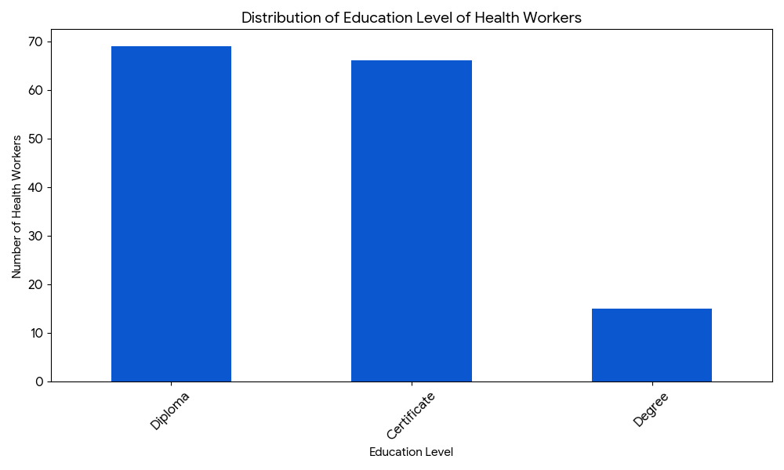

Figure 5: Distribution of Positions Held at Health Facility
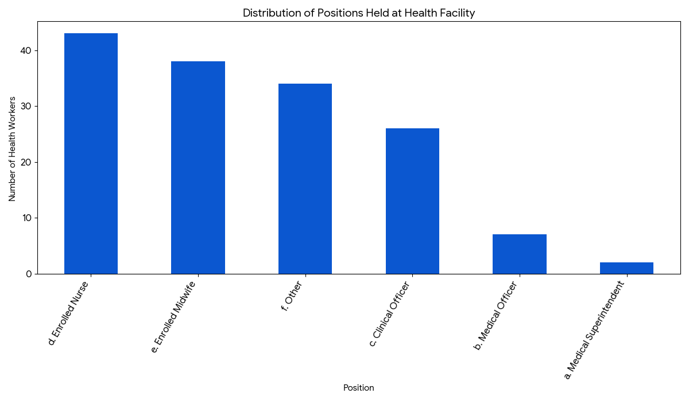

Training and Supportive Supervision on NTDs
A significant finding was the low prevalence of previous training on NTDs among health workers. Out of 150 respondents, 132 (88%) reported having no previous training on NTDs (soil-transmitted helminths, schistosomiasis), while only 18 (12%) had received such training (Figure 6). Similarly, regarding supportive supervision for NTDs, 126 (84%) health workers reported never having been visited for supportive supervision, compared to only 24 (16%) who had received it (Figure 7).
Figure 6: Previous Training on NTDs
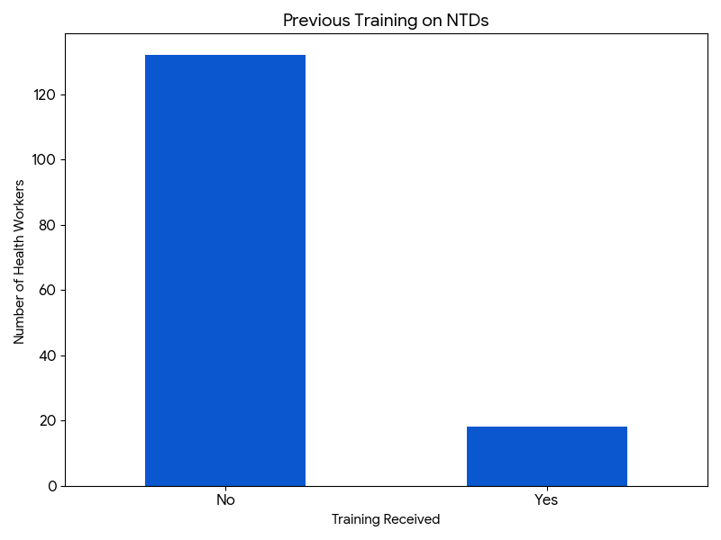

Figure 7: Supportive Supervision for NTDs
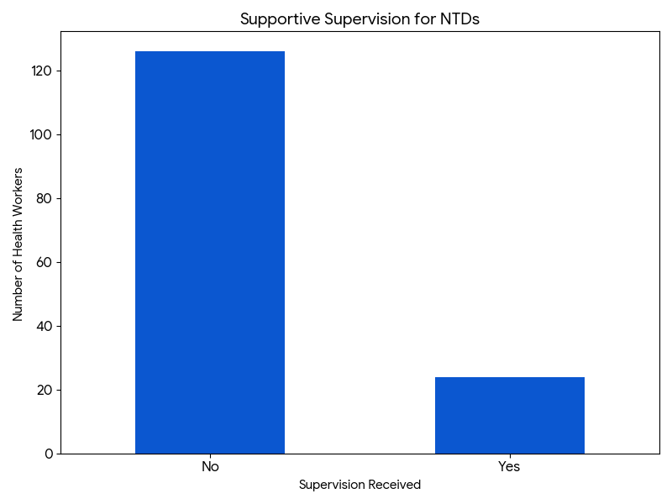

NTD Reporting Processes
The perceived ease of reporting NTDs varied among health workers: 39% (n=58) found the process 'Easy', 38% (n=57) found it 'Difficult', 17% (n=25) found it 'Very Difficult', and only 7% (n=10) found it 'Very Easy' (Figure 8). When asked if they found the NTD reporting form easy to fill in, a large majority, 71% (n=107), responded 'No', while 29% (n=43) responded 'Yes' (Figure 9). Regarding the impact of monetary incentives on NTD reporting, opinions were divided: 59% (n=88) believed they do not promote reporting, while 41% (n=62) believed they do *Figure 10).
Figure 8: Ease of Reporting NTDs
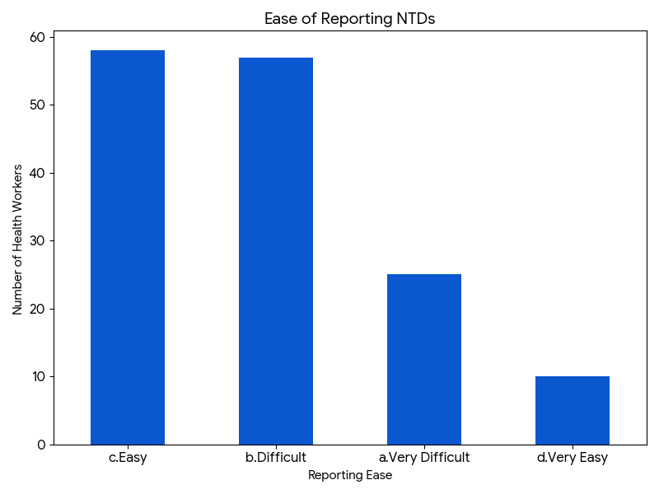

Figure 9: Reporting Form Easy to Fill In
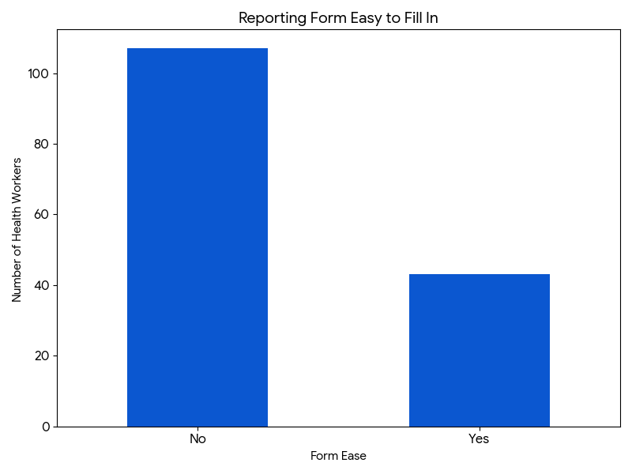

Figure 10: Monetary Incentives and NTD Reporting
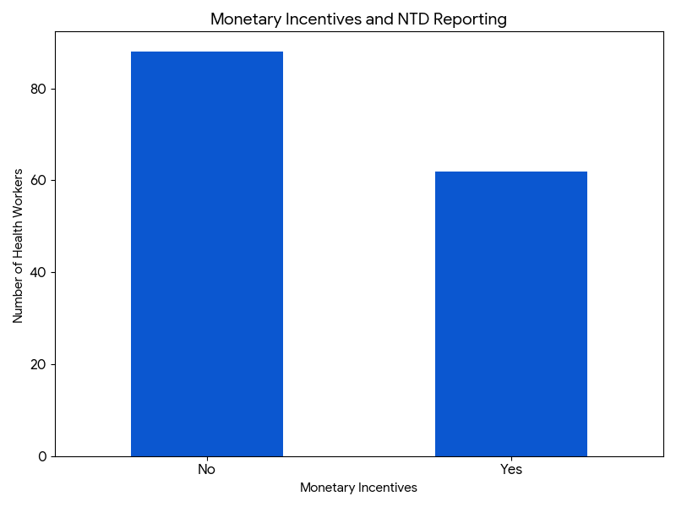

Knowledge of NTDs

Knowledge of Schistosomiasis and Helminth Subtypes:
- Schistosomiasis: 98 (65%) health workers reported knowledge of S. Haematobium, and 87 (58%) knew about S. Mansoni.
- Helminths: Knowledge of helminth subtypes was generally high: Hookworms (95%, n=142), Roundworms (92%, n=138), Tapeworms (91%, n=137), Flat worms (61%, n=92), and Flukes (61%, n=91).

Knowledge of Symptoms and Presentation:
- S. Haematobium Symptoms: The most frequently cited symptoms were Anaemia (n=125), Haematuria (n=121), Dysuria (n=84), Nephrotic colic (n=69), Oliguria (n=67), Asthenia (n=63), and Polyuria (n=58).
- S. Mansoni Symptoms: Common symptoms known included Abdominal pain (n=124), Anaemia (n=112), Diarrhoea (n=111), Bloody stool (n=110), Hematemesis (n=74), Hepatosplenomegaly (n=73), and Asthenia (n=63).
- STH Presentation: Health workers demonstrated good knowledge of STH presentation, with Abdominal pain (n=146), Anemia (n=139), Diarrhoea (n=126), Chronic Malnutrition (n=124), Reduced Immunity (n=123), and Cough (n=86) being the most recognized.

Knowledge of Medications:
- The most widely known medication was Albendanzole or Mebendazole for A. lumbricoides, T. Trichuris, and Hookworms (n=145). Praziquantel for Schistosomiasis was known by 111 (74%) respondents, and Ivermectin for S. Stercoralis by 82 (55%) respondents.

Discussion
This study aimed to assess the capacity of primary healthcare centers in Nakivale Refugee Settlement, Uganda, to diagnose and manage soil-transmitted helminths and schistosomiasis. The findings highlight critical areas concerning health worker knowledge, training, supervision, and reporting systems, offering insights into the current state of NTD management in this vulnerable setting.
Regarding the first specific objective, assessing health workers' knowledge of STHs and schistosomiasis, the results indicate a mixed level of understanding. While a high proportion of health workers demonstrated knowledge of common helminth subtypes (Hookworms, Roundworms, Tapeworms) and their associated presentations (abdominal pain, anemia, diarrhea), knowledge regarding schistosomiasis subtypes (S. Haematobium, S. Mansoni) was present but less universal. Similarly, key symptoms for both S. Haematobium (e.g., haematuria, anaemia) and S. Mansoni (e.g., abdominal pain, bloody stool) were widely recognized. Knowledge of medications, particularly Albendazole/Mebendazole for STHs and Praziquantel for schistosomiasis, was also relatively high. This suggests that health workers possess a foundational understanding of these NTDs. However, the striking finding that 88% of health workers had no previous formal training on NTDs is a significant concern. This lack of formal training aligns with findings from studies in Nigeria, Tanzania, and Burundi, which also reported low health worker capacity and readiness for NTD diagnosis and management [1, 17-18]. The existing knowledge might be acquired through informal means, on-the-job experience, or general medical education, but the absence of specific NTD training could lead to inconsistencies in diagnosis, treatment protocols, and overall management.
The second specific objective aimed to assess the availability of diagnostic tools, equipment, and medications. While the questionnaire did not directly assess the physical presence or quantity of diagnostic tools and equipment, the high knowledge of specific medications used for STHs and schistosomiasis (Albendazole/Mebendazole, Praziquantel) indirectly suggests that these medications are likely available or at least known to be part of the treatment regimen. However, the Ministry of Health has previously cited a lack of equipment as a hindrance to NTD elimination [23]. This study's focus on health worker knowledge, rather than a direct inventory of resources, represents a limitation in fully addressing this objective. Future research should incorporate direct assessments of resource availability.
The third specific objective focused on analyzing facilitators and barriers to diagnosing and managing NTDs. Several barriers were identified. The most prominent barrier is the severe lack of previous formal training and supportive supervision. Only 12% of health workers had received NTD training, and only 16% had received supportive supervision. This absence of ongoing education and mentorship is a critical impediment to enhancing health workers' skills and confidence in managing NTDs. Supportive supervision is crucial for reinforcing knowledge, addressing practical challenges, and ensuring adherence to guidelines. Its scarcity indicates a systemic gap in capacity building.
Furthermore, the reporting process for NTDs emerged as a significant barrier. A substantial proportion of health workers found the reporting process 'Difficult' or 'Very Difficult' (55% combined), and a large majority (71%) found the NTD reporting form itself not easy to fill in. This complexity and difficulty in reporting can lead to underreporting, inaccurate data, and ultimately hinder effective surveillance and program monitoring. Simplification of reporting forms and processes, potentially through digital solutions or more user-friendly designs, is crucial. The mixed opinions on whether monetary incentives promote reporting suggest that incentives alone may not be a panacea, or that their structure needs re-evaluation. Other non-monetary motivators, such as recognition, professional development, or improved working conditions, might also play a role in encouraging better reporting.
The context of a refugee settlement further amplifies these challenges. Overcrowding, poor sanitation, and barriers to healthcare access, as highlighted in the background, create a fertile ground for NTD transmission and make effective management even more challenging [20-22]. The findings of this study underscore that even with a basic level of knowledge, the systemic issues of inadequate training, supervision, and cumbersome reporting systems severely limit the capacity of the health system to effectively address NTDs in Nakivale.

Limitations
This study has several limitations. Firstly, it relied on self-reported data for knowledge and perceptions of reporting ease, which may be subject to recall bias or social desirability bias. Secondly, the questionnaire did not directly assess the physical availability of diagnostic tools and specific medications, limiting the depth of analysis for the second objective. Thirdly, being a cross-sectional study, it provides a snapshot of the current situation and does not capture changes in capacity or knowledge over time.

Future Research
Future research should consider qualitative studies to explore the underlying reasons for the low rates of NTD training and supervision, the specific challenges health workers face with reporting forms, and their perceptions of various types of incentives. Additionally, studies directly assessing the availability, functionality, and utilization of diagnostic tools and essential medications for NTDs in PHC facilities within refugee settlements are warranted to provide a more comprehensive picture of resource capacity.

Conclusion
The health care system in Nakivale Refugee Settlement faces significant challenges in its capacity to handle Neglected Tropical Diseases. While health workers possess foundational knowledge of common NTD types, symptoms, and medications, this knowledge is largely unsupported by formal training and consistent supportive supervision. The current NTD reporting system is perceived as complex and difficult to use, posing a substantial barrier to effective surveillance. To enhance the capacity of primary healthcare centers in refugee settings and accelerate progress towards NTD elimination goals, it is imperative to implement targeted interventions. These should include comprehensive and regular NTD-specific training programs, establishing robust supportive supervision mechanisms, and simplifying NTD reporting forms and processes. Addressing these systemic gaps will be crucial for improving NTD diagnosis, treatment, and management, ultimately improving the health and well-being of refugee populations.

References
[1] World Health Organization. (n.d.). Neglected tropical diseases. [2] Hotez, P. J. (2008). Neglected tropical diseases in the Anthropocene: The case for a new paradigm. PLoS Neglected Tropical Diseases, 2(10), e320. [3] Hotez, P. J., & Molyneux, D. H. (2008). Tropical diseases in the 21st century: The neglected diseases of neglected populations. PLoS Neglected Tropical Diseases, 2(10), e320. [4] Hotez, P. J., Molyneux, D. H., Fenwick, A., Kumaresan, J., Sachs, S. E., Sachs, J. D., & Savioli, L. (2007). Control of neglected tropical diseases. New England Journal of Medicine, 357(10), 1018-1027. [5] Hotez, P. J., Molyneux, D. H., Fenwick, A., Ottesen, E., Ehrlich Sachs, S., & Sachs, J. D. (2006). Incorporating a rapid-impact package of neglected tropical diseases control into AIDS, tuberculosis, and malaria control efforts: Opportunities for "de-neglecting" the neglected tropical diseases. PLoS Medicine, 3(5), e102. [6] Molyneux, D. H., Hotez, P. J., & Fenwick, A. (2005). "Rapid-impact interventions": How a policy of integrated control for neglected tropical diseases could benefit the poor. PLoS Medicine, 2(11), e336. [7] Hotez, P. J., Molyneux, D. H., & Fenwick, A. (2007). Neglected tropical diseases: The ancient afflictions of stigma and poverty. PLoS Neglected Tropical Diseases, 1(1), e11. [8] World Health Organization. (2017). Ending the neglect to attain the Sustainable Development Goals: A road map for neglected tropical diseases 2021–2030. [9] Hotez, P. J. (2007). The global burden of neglected tropical diseases. Public Library of Science Neglected Tropical Diseases, 1(1), e1. [10] Molyneux, D. H., Hotez, P. J., & Fenwick, A. (2009). Neglected tropical diseases and the Millennium Development Goals: Why the "bottom billion" cannot be forgotten. Lancet, 373(9670), 1570-1572. [11] World Health Organization. (2012). Accelerating work to overcome the global impact of neglected tropical diseases: A roadmap for implementation. [12] Hotez, P. J., Molyneux, D. H., Fenwick, A., & Savioli, L. (2009). Neglected tropical diseases in Africa: The case for a new paradigm. PLoS Neglected Tropical Diseases, 3(9), e486. [13] USAID. (n.d.). Act to End NTDs | East: Uganda. [14] World Health Organization. (2020). Ending the neglect to attain the Sustainable Development Goals: A road map for neglected tropical diseases 2021–2030. [15] Hotez, P. J., & Aksoy, S. (2018). Integrating neglected tropical diseases into primary health care. Lancet Global Health, 6(1), e2-e3. [16] World Health Organization. (2010). Working to overcome the global impact of neglected tropical diseases: First WHO report on neglected tropical diseases. [17] Okello, A. L., Nsereko, V., & Ocan, M. (2016). Knowledge, attitudes and practices of health workers on neglected tropical diseases in selected health facilities in Uganda. Journal of Public Health in Africa, 7(1), 517. [18] Mfinanga, S. G., Mmbaga, E. J., & Mchome, S. (2017). Knowledge, attitudes and practices of health care workers on selected neglected tropical diseases in Tanzania. PLoS Neglected Tropical Diseases, 11(11), e0006009. [19] UNHCR. (n.d.). Uganda Refugee Statistics. [20] Hotez, P. J. (2009). Neglected infections of poverty in the United States of America. PLoS Neglected Tropical Diseases, 3(6), e436. [21] Al-Adhroey, A. H., Al-Mekhlafi, A. M., & Mahmud, R. (2010). Leishmaniasis in Yemen: A review. Journal of Travel Medicine, 17(5), 332-339. [22] World Health Organization. (2018). Health of refugees and migrants. [23] Ministry of Health Uganda. (n.d.). National Neglected Tropical Diseases Control Program. [24] Ministry of Health Uganda. (2013). National policy for neglected tropical diseases control.

